R- Assignment on Advanced Classification

## Assignment 07

LAST NAME: SHAH

FIRST NAME: SARGAM

UTA ID: 1001275800

Dataset: IRIS DATA

Data Information: <http://archive.ics.uci.edu/ml/datasets/Iris>

Total number of tuples: 150

Iris Plant :

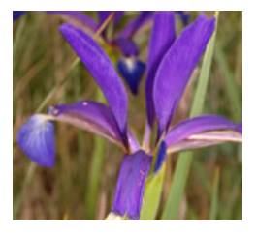

**Attribute Information:**

1. sepal length in cm   
2. sepal width in cm   
3. petal length in cm   
4. petal width in cm   
5. class:   
-- Iris Setosa   
-- Iris Versicolour   
-- Iris Virginica

Classifier: Neural Network

Code:

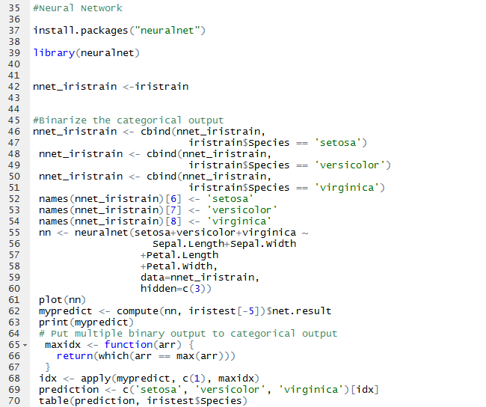

Output:

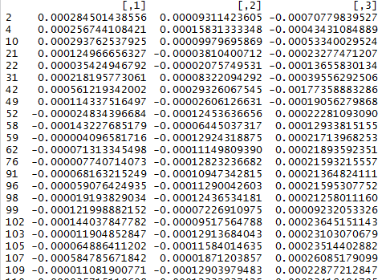

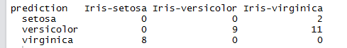

Plot:

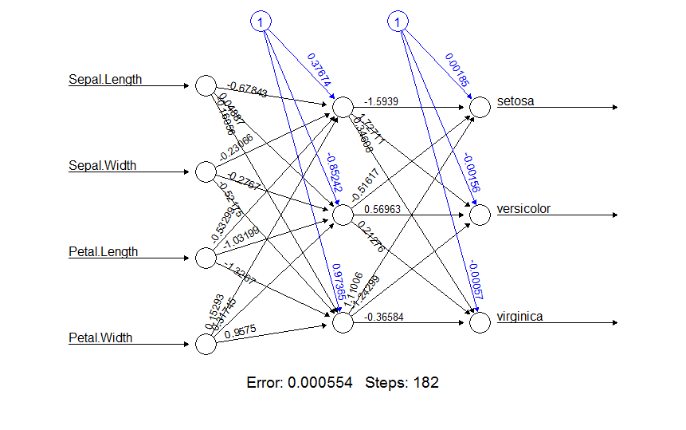

Analysis:

* The proposed model fails to classify iris-setosa. The precision and recall is 0% for this class.
* The neural network works perfectly fine in predicting iris-veriscolor. Its precision is 100 % and recall is 45%.
* Again, for iris-virginica, the proposed model is bad for predicting this class label.

Conclusion:

This model should not be applied for classification. The overall accuracy is just 30%.

Classifier: Naïve Bayes

Code:

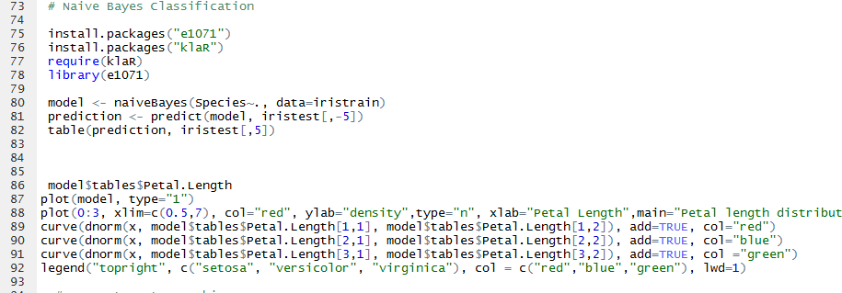

Output:

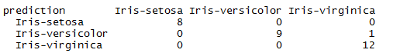

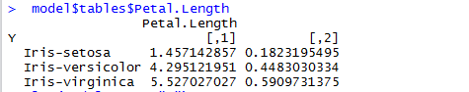

Plot:

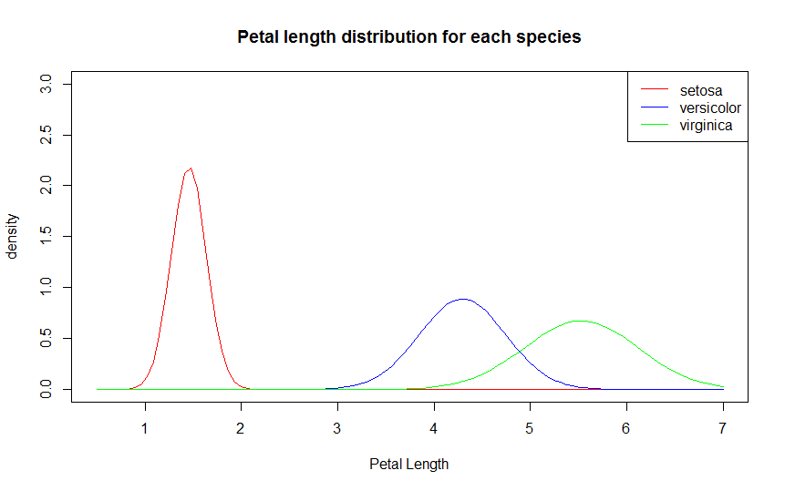

Analysis:

* For iris-setosa, precision and recall is 100%. Hence, it works well in predicting this class label.
* For iris-veriscolor, the precision is 100%. This means, it classifies all the petals which are actually versicolor with the correct class label. The recall is 90% which means it also classifies another petal which is not actually a versicolor to be a versicolor. However, it happens only 1 out of 10 times which is not that bad.
* For iris-virginica, the recall is 100%. It mean, it does not classify a sample belonging to any other class to be virginica. The precision is 92.3%. It means it classifies a sample which is actually a virginica to be something else. However, it happens only once in 13 times which is not that bad.

Conclusion:

This model works accurately with the Overall Accuracy of 96.66%. Hence, this model can be used to classify iris dataset.

Classifier: Support Vector Machine

Code:

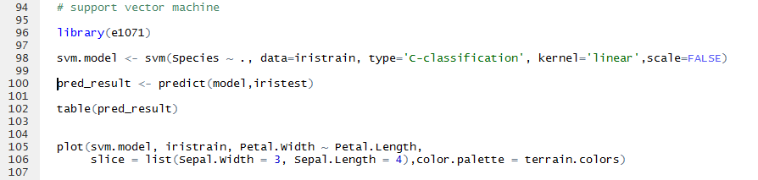

Output:

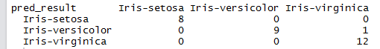

Plot:

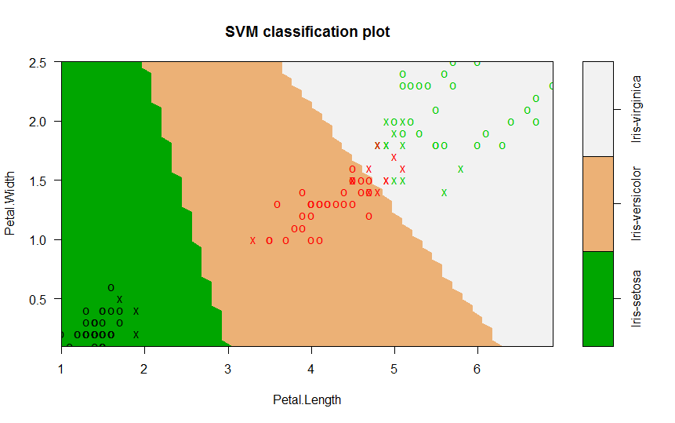

Analysis:

* For iris-setosa, precision and recall is 100%. Hence, it works well in predicting this class label.
* For iris-veriscolor, the precision is 100%. This means, it classifies all the petals which are actually versicolor with the correct class label. The recall is 90% which means it also classifies another petal which is not actually a versicolor to be a versicolor. However, it happens only 1 out of 10 times which is not that bad.
* For iris-virginica, the recall is 100%. It mean, it does not classify a sample belonging to any other class to be virginica. The precision is 92.3%. It means it classifies a sample which is actually a virginica to be something else. However, it happens only once in 13 times which is not that bad.

Conclusion:

This model works accurately with the Overall Accuracy of 96.66%. Hence, this model can be used to classify iris dataset.